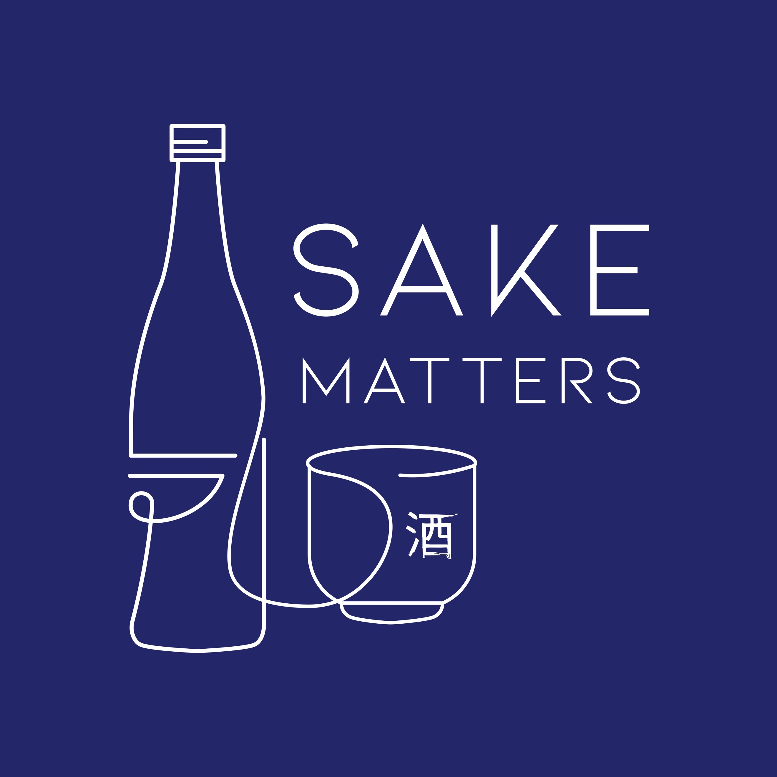

Dear Student

Thank you for your interest in studying Sake with Sake Matters Education & Training.

About Sake Matters Education & Training

Sake Matters Education & Training is one of WSET’s global Approved Programme Providers (APPs) and is licensed to teach the below WSET qualifications and to administer them in accordance with WSET Policy:
- WSET Level 1 Award in Sake
  - A beginner level introduction to sake for those starting a career in the industry or pursuing an interest in sake
- WSET Level 3 Award in Sake
  - An advanced level qualification for professionals working with sake or sake enthusiasts

Both WSET courses run by Sake Matters Education & Training are in-person with classes and exams organised at a given location in Quarry Bay which students attend as a group.

Pricing

Prices quoted are all-inclusive, including exam fees, tasting samples, textbook and all class materials. There are no hidden additional costs that a student is required to pay after enrolment.

For WSET Level 1 Award in Sake, a minimum of 8 tasting samples are included in the course fee. For WSET Level 3 Award in Sake, a minimum of 32 tasting samples are included. Students are not required to purchase samples themselves.

Please note that Sake Matters Education & Training cannot offer the WSET exam as an optional charge.

WSET Level 1 Award in Sake: HK$2,250
WSET Level 3 Award in Sake: HK$7,500

For reference, there is a charge for unsuccessful students who wish to resit the exam, as follows:
WSET Level 1 Award in Sake: HK$750
WSET Level 3 Award in Sake (Theory): HK$1,250
WSET Level 3 Award in Sake (Tasting): HK$750

Payment in full is required to reserve a place on the course.

Applying

If you would like to make a booking, please complete this page of this form and return it by email to hello@sakematters.com

Full name*
Sex (please tick) | Male o Female o [For exam registration]
Date of birth (DD-MM-YYYY)
Email address
Mailing address

Contact number (with country code)
Course (please circle one) | WSET Level 1 Award in Sake [taught in English]  WSET Level 3 Award in Sake [taught in English]
Course date (DD-MM-YYYY)
Please specify any special educational needs or disabilities
*Your legal name as it appears in your official photographic ID, which needs to be presented to sit the WSET exam(s). Please note, this information will be passed to WSET as per the Privacy & Data Protection policy of Sake Matters Education & Training.

Sake Matters Education & Training will confirm whether you have successfully reserved a place on the course within 3 working days. Successful students will be sent an invoice for payment by bank transfer once a place is reserved and payment in full is required to reserve a place on the course.

p [Please tick] I agree to the transfer of my personal information to WSET and its approved third-party providers and regulators.

Data passed to WSET by Sake Matters Education & Training will be handled in accordance with WSET’s Privacy Policy. Students may refer to WSET Privacy Policy for further details at https://www.wsetglobal.com/privacy-and-cookie-policy A copy of the Privacy & Data Protection policy of Sake Matters Education & Training is available on request. Should you have any further questions, please reach out to William Jarvis [hello@sakematters.com].

Signed

_________________ _________________ _________________
Signature Name Date

More Information

Included below are the following links to documents to help with your application:
- The specification for WSET Level 1 Award in Sake
- The specification for WSET Level 3 Award in Sake

On request, the following policies are also available for review:
- Complaints & Appeals  - Conflict Of Interest  - Diversity & Equality  - Refunds & Cancellations | - Malpractice & Maladministration  - Privacy & Data Protection  - Special Consideration  - Reasonable Adjustment(s)

Should you wish to discuss any special education needs or you have any other questions, please reach out to William Jarvis [hello@sakematters.com].

UNDER THE LAW OF HONG KONG, INTOXICATING LIQUOR MUST NOT BE SOLD OR SUPPLIED TO A MINOR IN THE COURSE OF BUSINESS.
根據香港法律，不得在業務過程中，向未成年人售賣或供應令人醺醉的酒類
Top of Form
Bottom of Form

